**外国人在中国境内临时住宿申请手续**

Procedures for Foreigners' Temporary Accommodation in China

1．外国人在宾馆、饭店、旅店、招待所、学校等企业、事业单位或者机关、团体及其他中国机构内住宿，应当出示有效护照或者居留证件，并填写临时住宿登记表。

Foreigners staying in hotels, restaurants, inns, guesthouses, schools, enterprises, institutions, organizations, or other Chinese establishments should present a valid passport or residence permit and fill out a temporary accommodation registration form.

2．外国人在中国居民家中住宿，在城镇的，须于抵达后二十四小时内，由留宿人或本人持住宿人的护照、证件和留宿人的户口薄到当地公安机关(派出所)申报，填写临时住宿登记表。

Foreigners staying in Chinese residents' homes in urban areas must, within 24 hours of arrival, have the host or the foreigner themselves, with the host's passport, documents, and the host's household registration book, report to the local public security bureau (police station) and fill out a temporary accommodation registration form.

3．外国人在中国的外国机构内或在中国的外国人家中住宿，须于住宿人抵达后二十四小时内，由留宿机构、留宿人或者本人持住宿人的护照或居留证件，向当地公安机关（派出所）申报，并填写临时住宿登记表。

Foreigners staying in foreign institutions or in the homes of foreigners in China must, within 24 hours of the arrival of the lodger, have the lodging institution, the host, or the foreigner themselves, with the lodger's passport or residence permit, report to the local public security bureau (police station) and fill out a temporary accommodation registration form.

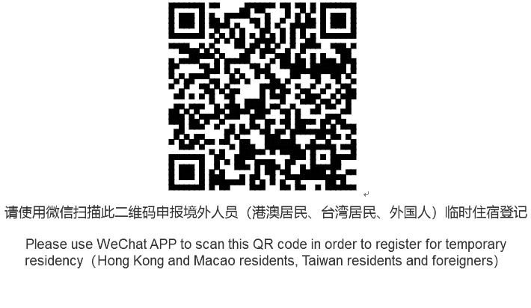

**住宿登记样本：**

**Sample Accommodation Registration Form:**

